**Adak (Hero Dog)**

Adak, a German shepherd, served with the U.S. Department of State and with the Army in Iraq and Afghanistan for several years, sniffing out explosives. On Jan. 14, 2008, Adak worked during an active terrorist attack on a Kabul hotel, helping Americans evacuate victims and find terrorists (Suneson & Harrington, 2018).

**Cooper (Working Dog)**

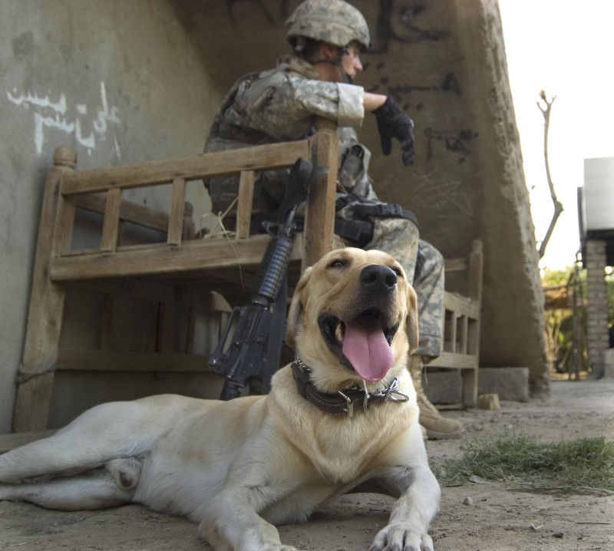

20-year-old Corporal Kory Duane Wiens followed in the footsteps of his grandfather and namesake, a military canine handler during the Korean War, when he became a member of the 94th Mine Dog Detachment, 5th Engineer Battalion, 1st Engineer Brigade, serving in Iraq in 2007. Wiens’ canine comrade was a yellow Lab named Cooper, and they formed a closely bonded team. They worked together to find firearms, ammunition, and explosives. While on patrol in Muhammad Sath, Iraq on July 6th, 2007, Wiens, and Cooper were killed by an improvised explosive device. Their remains were buried together in Wiens’ hometown of Dallas, OR (Admin, 2020).

**Max (Companion Dog)**

Max, who lives in Keswick in Cumbria, became a social media star after helping his owner, Kerry Irving, recover from a road traffic accident. Unable to walk, Irving developed severe depression. Two years after the crash he met Max, who gave him a reason to walk again and was soon given the mantle Max the Miracle Dog. Irving said: “When I was at my lowest, Max became my reason to live, and he continues to make me smile every day. Being able to share the support, comfort, and joy that Max brings to thousands of people has been a privilege” (Pidd, 2021).



Image retrieved from https://thecitylane.com/adopt-a-pet-on-national-adoption-day/



Image retrieved from https://paulgcook.org/2020/08/16/my-webinars-with-emplify-and-button/

**References**

Admin. (2020, November 11). *5 inspiring stories of War Dogs*. DogTails. https://dogtails.dogwatch.com/2016/11/11/5-inspiring-stories-of-war-dogs/

Pidd, H. (2021, February 19). *Max the miracle dog is first pet to receive “animal OBE.”* The Guardian. https://www.theguardian.com/lifeandstyle/2021/feb/19/max-the-miracle-dog-is-first-pet-to-receive-animal-obe

Suneson, G., & Harrington, J. (2018, July 11). *The 25 most heroic dogs in America*. USA Today. https://www.usatoday.com/story/life/people/2018/07/05/25-most-heroic-dogs-america/761906002/